# Leather Strap Chronograph Watch

Price: $170.00 Color: Black

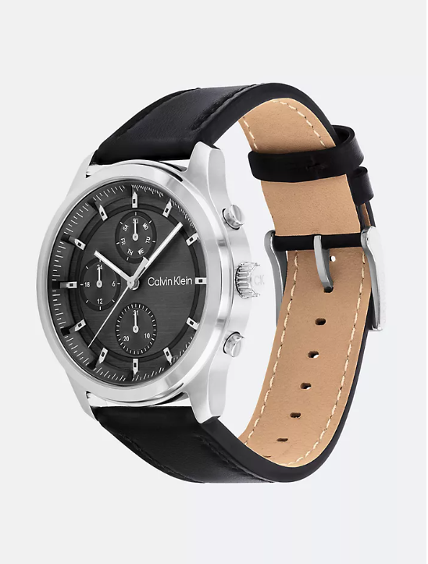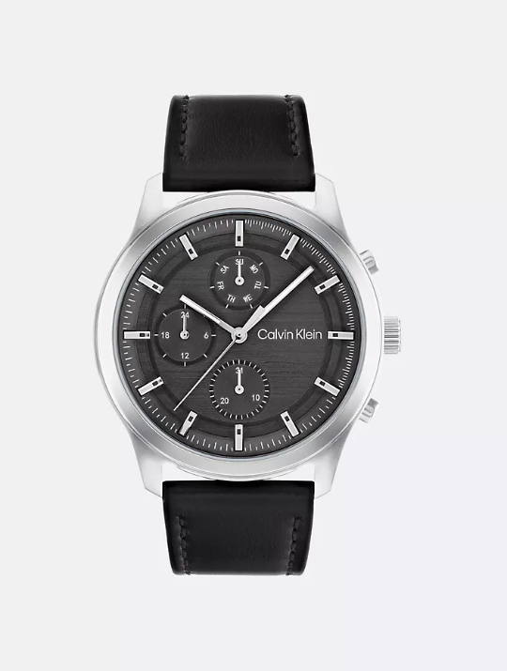

## **About the Leather Strap Chronograph Watch:**

Industrial, bold style. Horizontally brushed, multi-eye dial featured on a smooth leather strap.

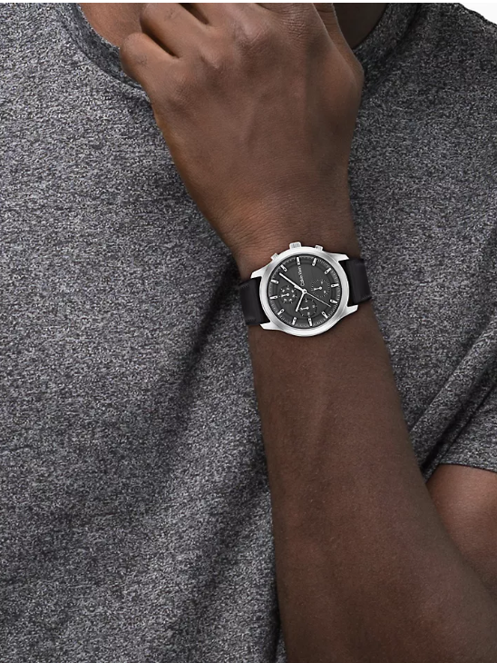**Product Details:**

* Stainless steel or black IP coated case
* Leather strap
* Tongue buckle closure
* Chronograph design
* Quartz movement
* 44mm case size, 23mm lug width
* Water resistant 3 bar
* 2 year international warranty
* All watches + jewelry come in a box

Style #: 43042110-001

Universal Style #: 25200211